Unity Team
Matteo Dell’Oro, Alfio Giuliano Faro, Gabriel Logronio

LEVEL DOCUMENT

Purpose | Document giving an overview of the level, with areas descriptions, script and charts.
Creation date | 11-12-2017
Current owner | Gabriel Logronio
Last modification | 27-12-2017

Revision History
Who | When | What
Faro | 22-11-2017 | Created this document
Faro | 23-11-2017 | Added setting
Faro | 24-11-2017 | Added Script
Dell’Oro | 12-12-2017 | Added areas’ descriptions
Faro | 17-12-2017 | Created buildings’ interiors
Faro | 19-12-2017 | Modified buildings’ interiors
Logronio | 20-12-2017 | Organized this document
Logronio | 27-12-2017 | Added descriptions and cutscenes references

GOAL OUTLINE

1. Explore the city

a. Get the supplies from the shop’s warehouse

b. Find a way into the city

c. Explore the city to find clues
(Optional) Find the scientists’ pass

d. Get past the cybermen’s Guard Post

e. find the light’s source

2. Get to the factory

a. Exit the building from the rear entrance

b. Get through the mine field and deactivate to generators

c. Find a way into the factory
(Optional) Find another way into the factory

3. Free the factory

a. Explore the factory to find clues
(Optional) Free all the scientists

b. Find the pass to use the lift

c. Hack the right terminal

d. Use the lift to get the control room

4. Defeat Strax

AREAS’ and BUILDINGS’ DESCRIPTIONS

LEGEND:
- Ⓢ Setting description - Ⓖ Gameplay description - Ⓓ Details

① Gas station
Ⓢ- The group lands with the Tardis in the outskirts of a town, nearby a little rundown gas station with a shop on the road heading to the same city. The area is surrounded by a desert, with the air dry and dusty. The vegetation is poor, with just sporadic weeds and brambles growing here and there and some grass that have gone totally dry and yellowed, the ground is dry and bright brown. All together they make the landscape desolated and in ruins, as the sun is setting down. There is nobody around.
Ⓖ- The player is taught how to use Jenny's “Hack it!” skill and solve the relative puzzle. The player has to learn it in order to open the gas station’s warehouse, where he can find a substantial reward.
Ⓓ- ENEMIES: None -LOOT BOXES: (?)
Scripted sequence 1

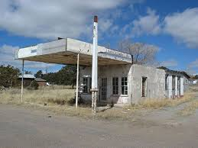
(A gas station in ruin near the landing point)

② Road leading to the town
Ⓢ- Not far from there the town can be noticed. A road links the gas station to the town: it is dismissed as nobody has used it for centuries, there are many holes where sporadic grass manage to grow, the guard rails are in ruin but still up not to allow the player to exit the road. The music and the environment create a calm but creepy atmosphere.
Ⓖ- The player has to go towards the town. The city door will need to be unlocked with “Hack it!”, to test if the player has actually learned the skill.
Ⓓ- ENEMIES: None -LOOT BOXES: None
Scripted sequence 2

③ Town Square
Ⓢ- The houses and the streets are just ruins of what they used to be. From a building the light from a huge factory can be seen and its noises resound through the walls. People who used to live there are disappeared, just few rabid dogs manage to live in the area also patrolled by cybermen.
Ⓖ- Once in the city, the player will have to fight the first enemy right after opening the door. After that, the player is free to roam the various buildings/areas connected. The player can engage different enemies, use Alros' Climb in the middle fountain (to get a reward), or find a reward between houses 1 and 2. The Boulevard is directly accessible while the Market can only be accessed through house 4. At the end of the boulevard a scripted sequence starts showing the first sight of the factory at the horizon.
Ⓓ- ENEMIES: Cybermen (?) - LOOT BOXES: 1 x (?)
Scripted sequence 3

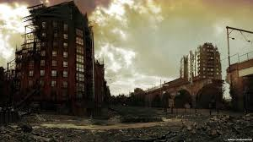

(A view of the city, with buildings in ruins and a bridge)

Buildings:
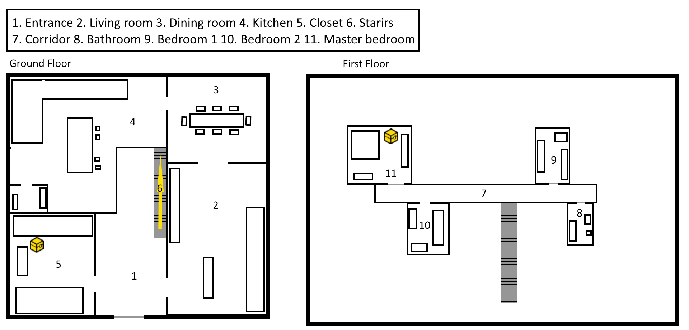 | Ⓐ - House  A simple house in ruin that used to belong to a family. It allows exploration without enemies and gives small rewards.  ENEMIES: None  LOOT BOXES: 2 x (?)
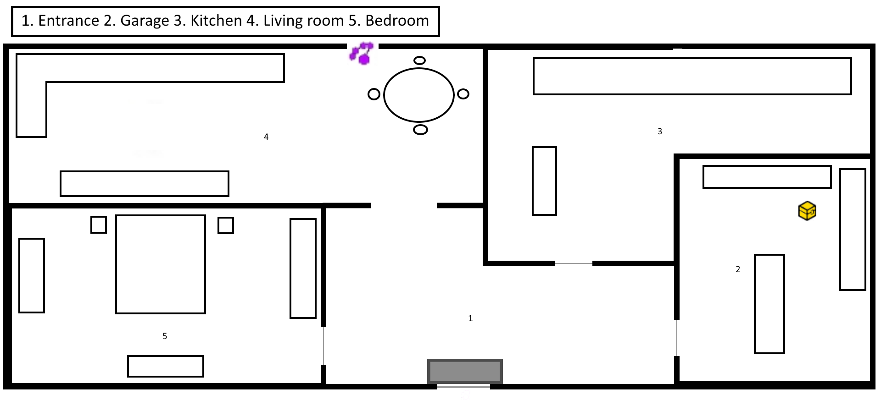 | Ⓑ - House  The player needs to use Hack in order to enter the house from the back entrance as the front door is blocked from some debris, once inside a reward can be found.  ENEMIES: None  LOOT BOXES: 1 x (?)

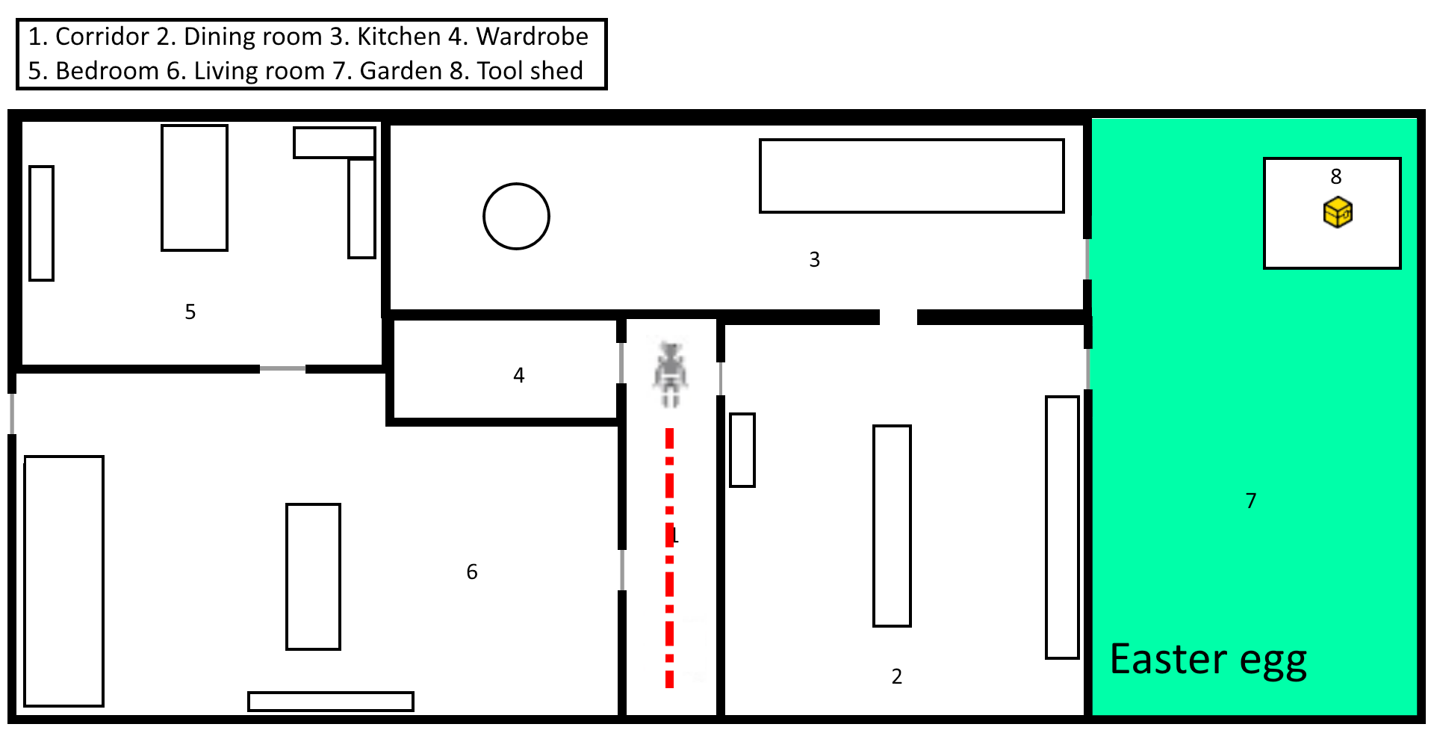 | Ⓒ - House  In order to enter this house, an enemy has to be killed. Once inside, a substantial reward will be found with nearby an Easter egg.  ENEMIES: cyberman (?)  -LOOT BOXES: 1 x (?)
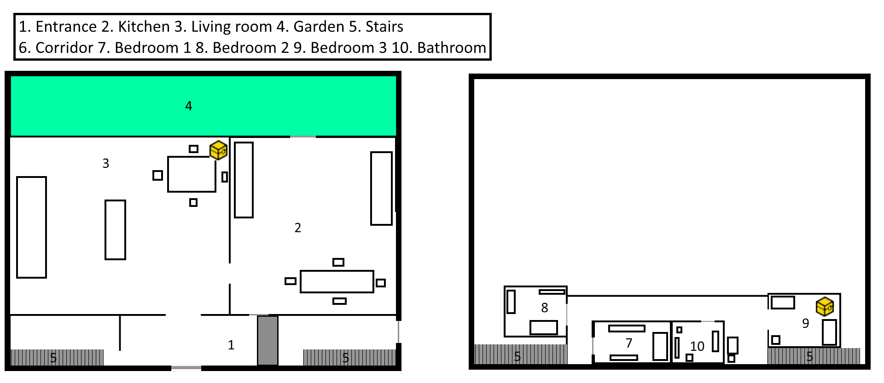 | Ⓓ - House  On the ground floor a reward can be found. On the second floor the pass, which can be used in order to skip the guard post fight, can be found with a little bit of exploration. The right side exit of the building leads to the Market.  ENEMIES: None  LOOT BOXES: 1 x (?) + Pass
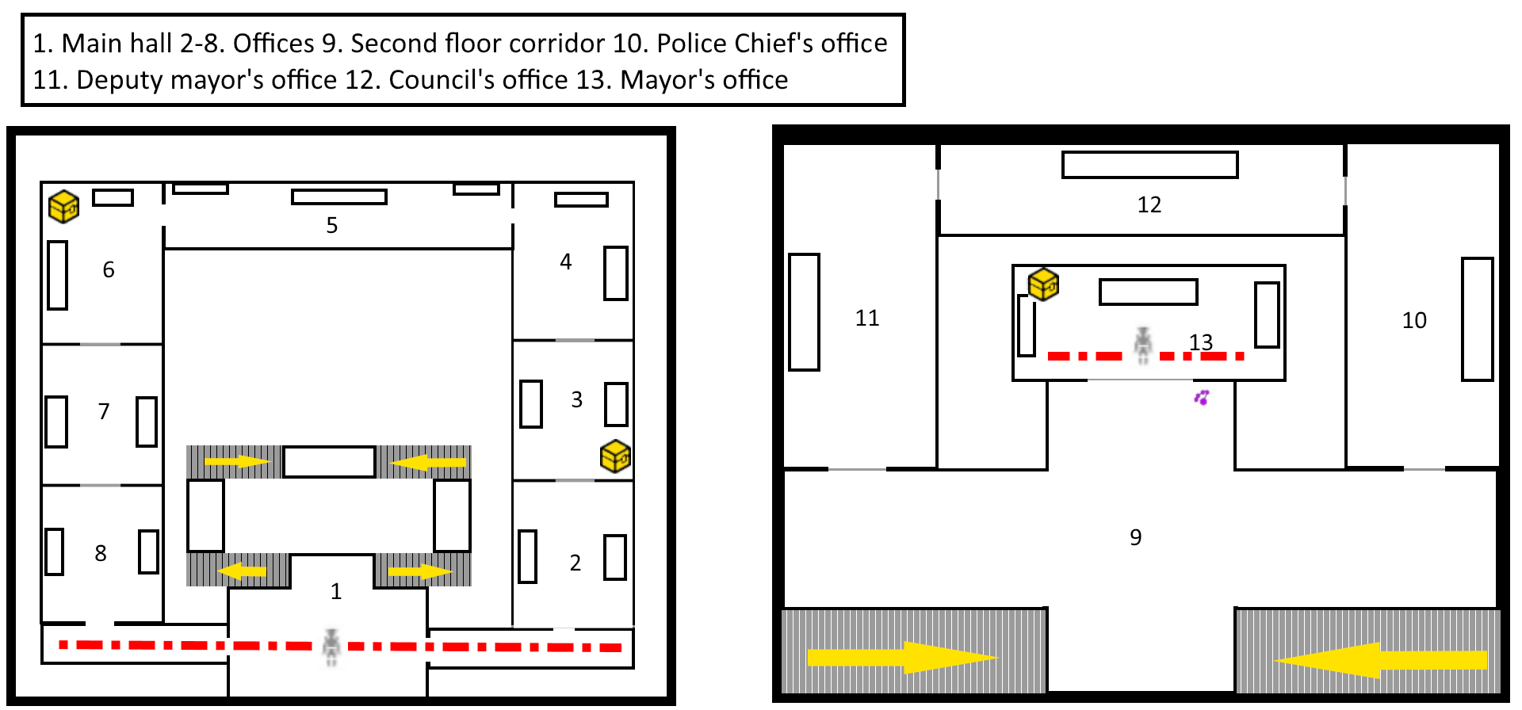 | Ⓔ - City hall  The City Hall is the main building of the Town Square. Once inside, the player will have to fight an enemy near the door and a reward can be find in a corner. On the second floor instead, a door is locked but Hack can be used on it; once inside an enemy will be found guarding a reward.  ENEMIES: cybermen (?)  LOOT BOXES: 3 x (?)

④ Market
Ⓢ- The market is an abandoned area, filled with stands in ruin filled with only dust. Coins on some stall and on the ground try to remind how lively the place used to be centuries before, now the sound of the voices is replaced by the howls of the wind and the barks of some rabid dog.
Ⓖ- The market is a large area where the player can roam around and explore. Two enemies can be found, one just outside House 4 and one behind the stands in the corner. On the bottom-right corner, Alros' Climb can be used to get on top of the guard post of the Boulevard, where a skylight will let the player see the composition of the enemies inside it.
Ⓓ- ENEMIES: cybermen and rabid animals (?)-LOOT BOXES: 1 x (?)

⑤ Boulevard
Ⓢ- The boulevard used to be the main residential area of the city, the houses overlooking have the doors blocked by ruins, debris or simply locked like someone checked each of them to be sure they were empty and nobody could go back in. It is unclear how but some lights are still working. The guard post is in ruin but held together with metal plates and nails. From a building the light from a huge factory can be seen and its noises resound through the walls.
Ⓖ- The Boulevard is a long straight street, without much possibility to explore around. At about half way through, a guard post has a big group of enemy inside. They can be challenged for a reward, or skipped (only if the player found the pass in House 4). On the left pathways leading to the Town Square and the Market can be found, while on the right the entrance of the Building with the light can be found.
Building with the light- Place of key importance for the story: a scripted sequence will play once inside it, showing the rear door and the light coming from the factory. In the bottom-left corner, a small reward can be picked up.
Ⓓ- ENEMIES: cybermen -LOOT BOXES: 1 x (?)
Scripted sequence 4, 5
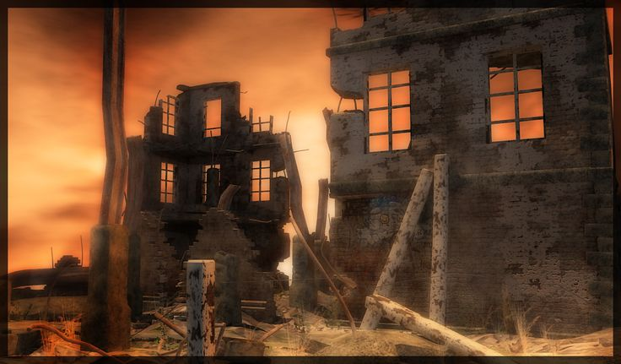
(The view of the factory from the town)

⑥ Mine field
Ⓢ- The place is in the middle of a desert area with four small sheds containing computers and a big pylon in the middle of it. The vegetation is still very poor but incredibly lively compared to the rest of the level: the hundreds of dead body of the people who died in here have kept the ground not too much dry, on the other hand the vegetation is glowing red instead of the more usual green.
Ⓖ- Clara separates from the group, and starts the puzzle: the player must guide her find a way through a mine field to debilitate the 4 generators that feed the area, following the cybermen's path and hiding behind obstacles.
Ⓓ- ENEMIES: cybermen (?) -LOOT BOXES: None

⑦ Factory Entrance
Ⓢ- The exterior of the factory is extremely well kept compared to the city, someone wanted to be sure it to be sabotage proof: the walls are covered of barbed wires, the gate is well guarded and filled with spotlights that cast long and creepy shadows. A river separates the factory from the mine field, with a little bridge largely unscathed linking them, and a big drainage pipe pours smelly but clean water into it.
Ⓖ- Main Door- Main entrance to the Factory, easily visible but strongly defended. It can be accessed only after the mine field puzzle has been solved.

Sewers- Side entrance to the Factory, barely visible but without any direct defence. As with the main door, it can only be accessed after the mine field puzzle has been solved.
Ⓓ- ENEMIES: cybermen (?)- LOOT BOXES: None
Scripted sequence 6, 7, 8

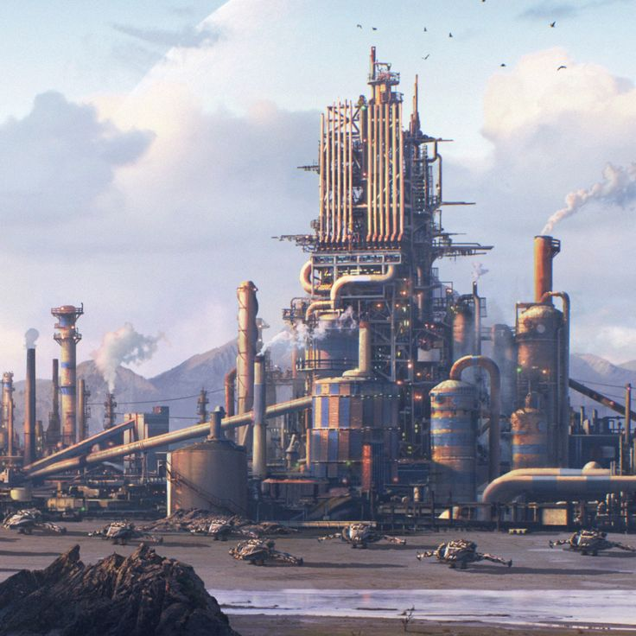
(A view of the factory from afar)

⑧ Factory
Ⓢ- The factory has a huge courtyard with some buildings, tanks, tubes, drills, bulldozers and quite a lot of materials used in the works. In the middle of the factory there’s a big tower.
The corridors are wet and long, with some artificial neon on the roof. The predominant colour are grey and black, with the tubes looking heavy and rusted. A strong smell of chemical agents is in the air, inside the rooms and the corridors. The corridors are patrolled by some cybermen. The atmosphere is oppressive, the ambient is claustrophobic and the presence of cybermen make you feel haunted.
Inside a room you can find monitors, tables and some papers written by the scientists that work there.
Some rooms are laboratories, where scientists work under the supervision of some cybermen.
On the top floor of the tower, you can find the control room where Strax is located. This is a huge room with one big window in front of the entrance door, where you can look the landscape of the factory and the places around it. Just under the window there is a big desk with computers, monitors, buttons, and a chair where Strax is seat. The room is very bright, different from all the other rooms in the factory, the walls are white and the floor is polished and clean, made out of a bright and perfect grey material. The air inside is fresh and clean, not even outside the factory it is this pure. This room transmits a sensation of calmness, but you feel the electricity in the air, like that “calm before the storm”.
Ⓖ- Biggest part of the Factory, where the player is free to roam around. Many guards patrol most of the paths, and a reward can be found in the bottom-right corner. Warehouse 1, 2 and 3, Building 1 and Building 2 can be accessed through various means. The tower can't be directly accessed: many guards control the direct entrance, and even if the player manages to take them out, the gate gets locked.
Ⓓ- ENEMIES: cybermen- LOOT BOXES: 1 x (?)
Scripted sequence 9, 10, 11, 12
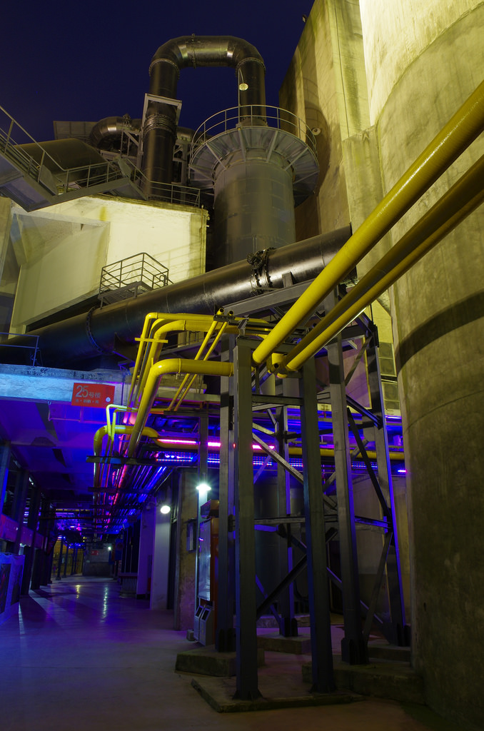
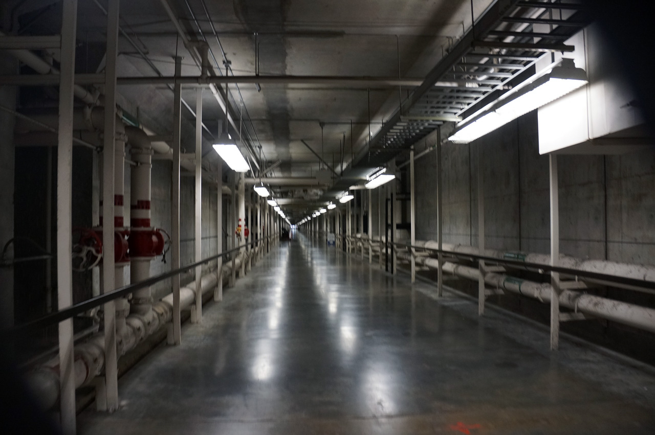

(A view from inside the factory, we can see tanks and tubes in the yard and a corridor inside a building)

Buildings:
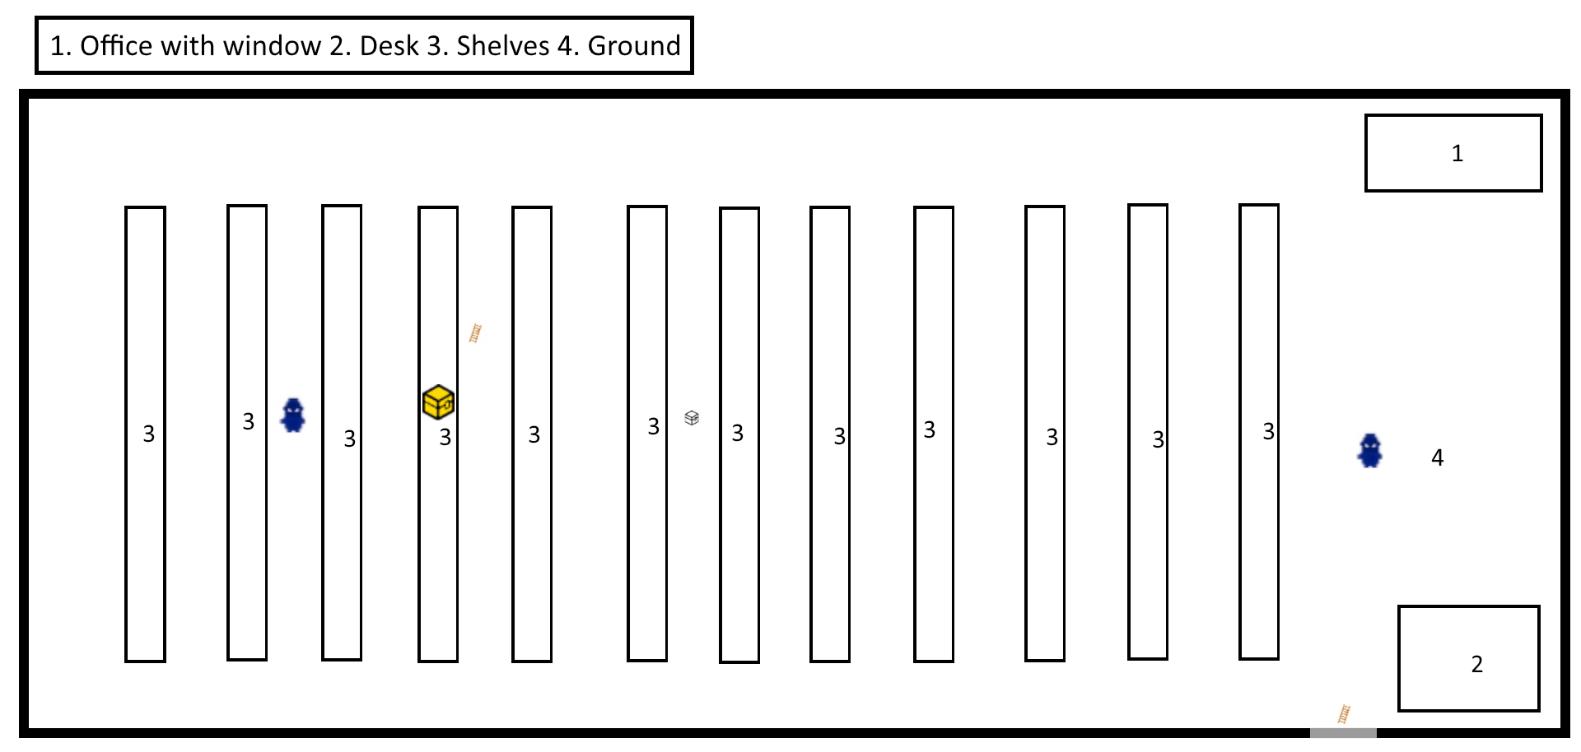 | Ⓕ - Warehouse  While the door is locked, Climb can be used in order to have Alros reach an opened window from where he can get inside the building and open the door from inside. A reward can be found once those steps have been fulfilled.  ENEMIES: sontarans (?)  LOOT BOXES: 1 x (?)
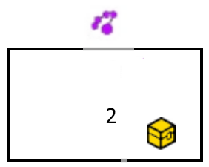 | Ⓖ - Warehouse  A tiny room, with the door locked but accessible using Jenny's Hack. A reward can be found inside.  ENEMIES: None  LOOT BOXES: 1 x (?)
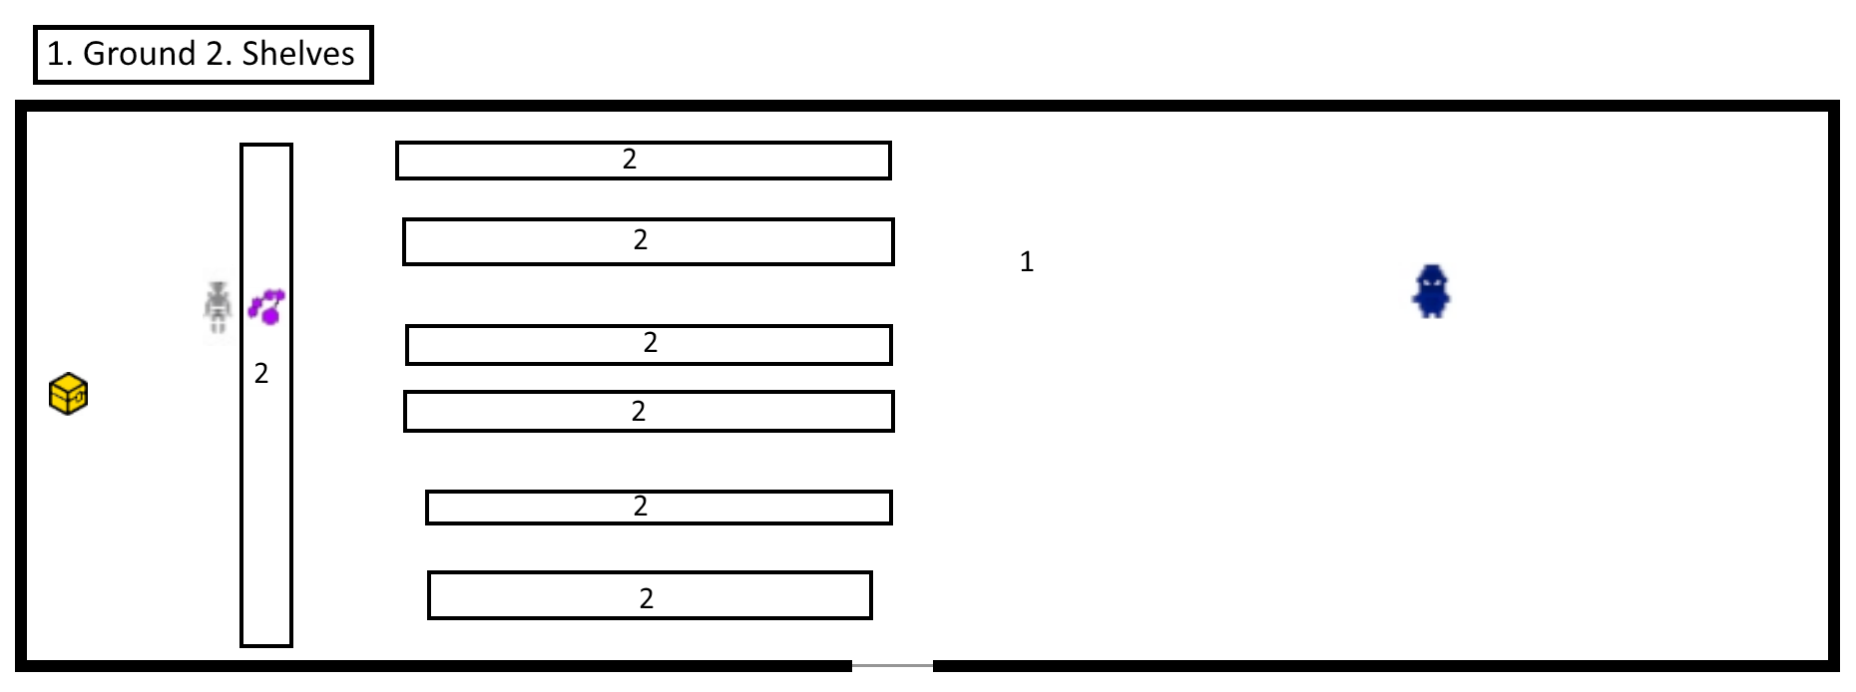 | Ⓗ - Warehouse  A small and empty building with an enemy inside guarding the computer used to increase the pass permission.  ENEMIES: sontarans and cybermen  LOOT BOXES: 1 x (?)
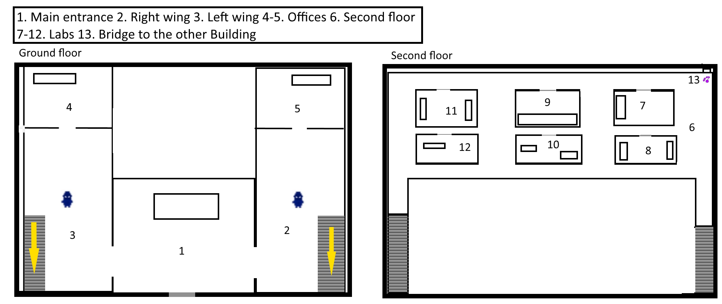 | Ⓘ - Building  First of the two buildings where scientists can be found; while the ground floor is empty, the upper floor contains an enemy guarding a reward, and the possibility of using Hack in order to unlock a narrow bridge that leads directly to Building 2 upper floor.  ENEMIES: sontaran and cybermen  LOOT BOXES: None

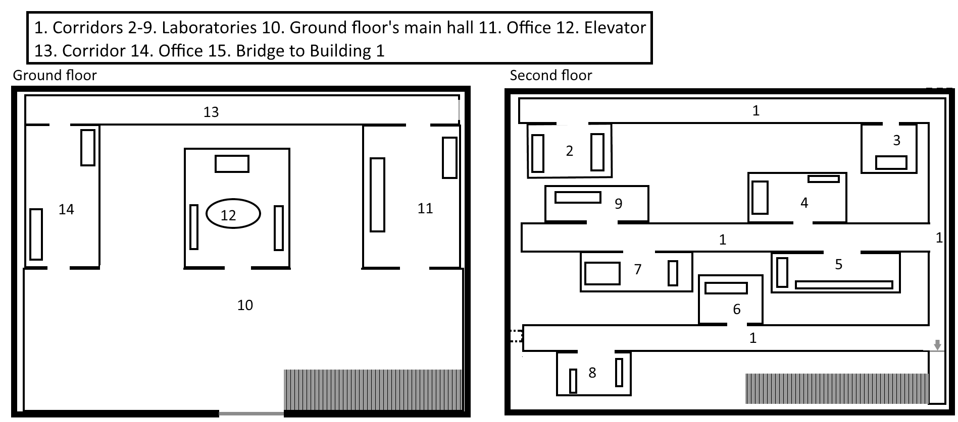 | Ⓛ - Building  Key building of the Factory complex, where the player has to complete the Scientist event in order to have the pass that unlocks the Tower's elevator. An enemy will be challenged in the Scientist event, but no rewards are located inside the building. The door in the second floor needs to be unlocked from the side of the arrow.  ENEMIES: None  LOOT BOXES: None
 | Ⓜ - Tower  Ground Level  The outside of the tower, with a front entrance and a rear entrance. Entering the tower through the front entrance triggers a battle with the main gate guards, who close the entrance. Inside there are two identical elevators, at North and South sides, actionable only after getting the pass and the permission.  ENEMIES: None  LOOT BOXES: None
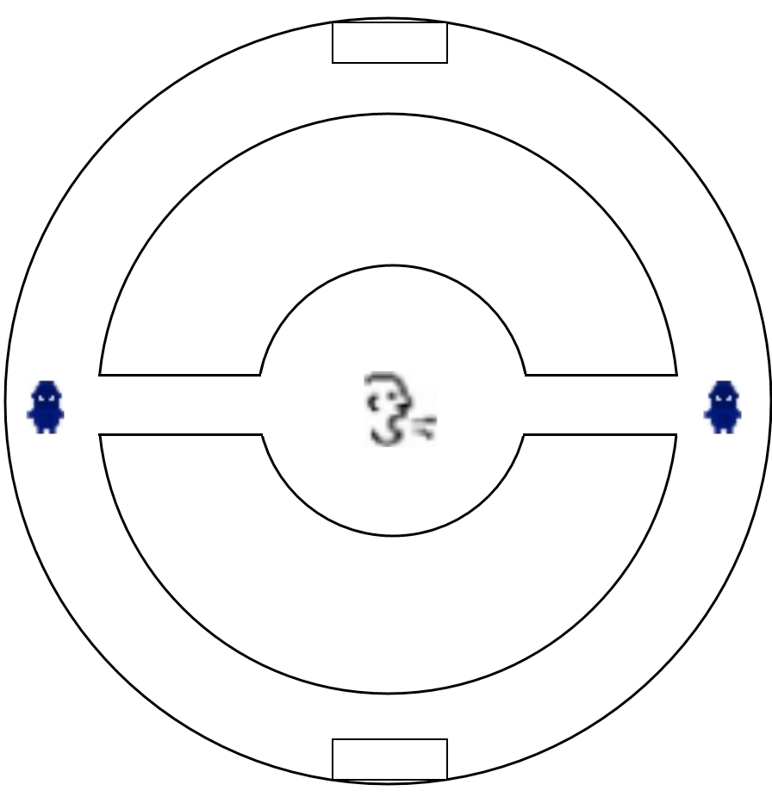 | First level  Once inside the elevator, the player can choose between going to Floor 1 or Floor 2. Two different enemies are guarding the entrances to the tower core room, where Jack's Charisma can be used in order to obtain a big reward from the scientists inside.  ENEMIES: sontarans  LOOT BOXES: 1 x (?)
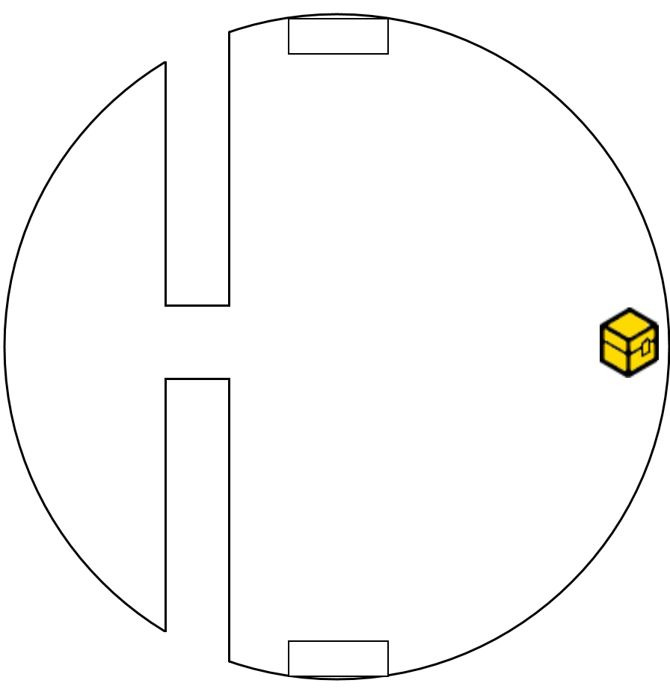 | Second Level  On floor 2, a reward can be found on the East side consisting in items useful to face Strax, the final boss. On the West side on the other hand is where Strax's room is located: entering it will trigger the boss fight.  ENEMIES:  LOOT BOXES:
LEGEND
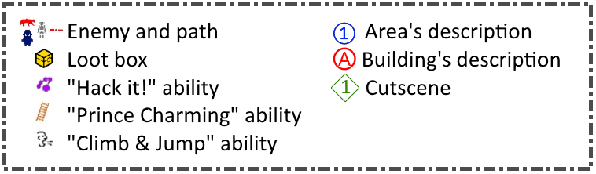
CITY MAP
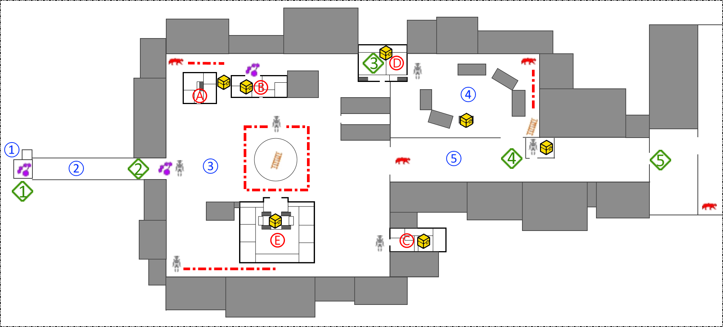
FACTORY MAP
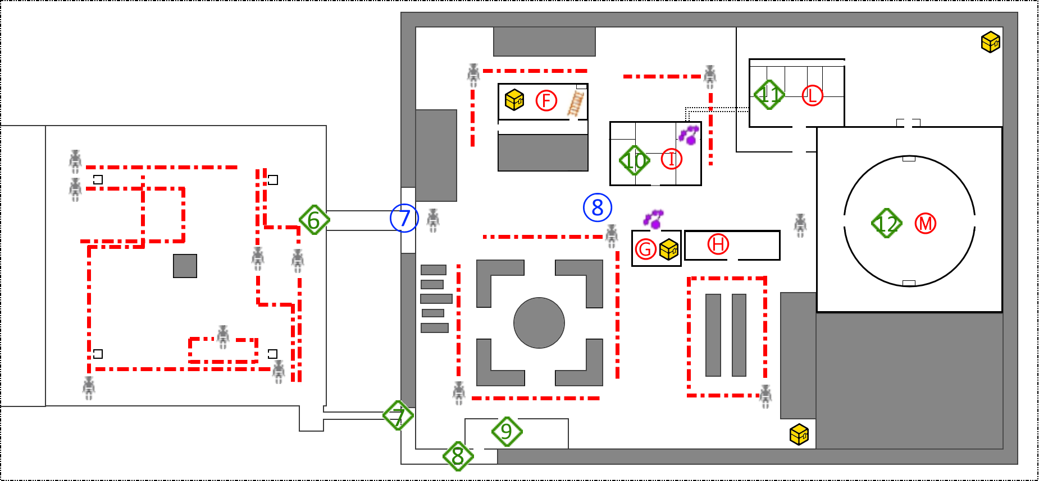

Script
In the dialogues lines will be divided between Alros, Ashildr(Me), Clara, Jack, Jenny.

Script | Type and description
"Finally we have landed" Jack says after that the Tardis stopped.  The group gets out the Tardis. "Where are we?" asks Jenny while looking around. "I think we’re still on Earth" answers Clara, "Look there, it seems like a gas station or a little shop".  "Let’s hope we find other beautiful travelling companions here" says Jack, looking at the girls, as they roll their eyes and snort at Jack's sentence.  The group heads to the gas station, once inside Ashildr says "Looks like they ran away in a hurry" while checking around with her weapon ready to fire.  "It's strange" Alros picks up a bowl containing some beans, now dented and mouldy, "they fled so quickly that they didn't even take away all this food!".  Me glances at Clara and says "I think we better check this place quickly and then leave". | Scripted sequence with dialogue  1
Inside a part of the roof is broken with the sun coming in. In the sky the last daylight is leaving early in the evening. No one is inside, but products are still on the shelves. The team can find some consumables items on the shelves. Jenny hacks a terminal in order to access the storage room in the back, where they find other useful resources. They then exit the small shop and head to the nearby town | Playing time with a puzzle
While walking around Clara asks Alros why he is so silent. "I'm worried about my brother, I hope he’s OK. I need to find him".  "Don't worry, I'm sure he is fine!" says Clara trying to reassure him. | Scripted sequence with dialogue  2
The party follows the road until they reach a little town, now in ruins. The buildings are destroyed due to neglect and bad weather and the dust covers the streets. Here and there some plants can be spotted, but they’re just trunks without life. Jenny hacks the gates terminal and they get in but are immediately attacked by a group of patrolling cybermen. After defeating them they examine the body and find a radio signal heading to a nearby place, then they proceed to look around the city hoping to find something interesting. | Playing time with a puzzle
In a building they find a fresh corpse of someone who looks like a scientist with a badge still in his hand, with a note saying: “Dear Laura, we managed to escape,I’ll come back to free you too, just wait for me, your Mickey” Me picks it up saying “He won’t need it any more”. While exploring towards the source of the signal they get to a guard post filled with cybermen but they strangely do not attack on sight. | Scripted sequence with dialogue  3
On of the cyberman says “Show me your badge” with his rusty robotic voice. Me rapidly takes the pass that she previously got and shows it to the cybermen and they let the team pass without attacking them.  “That was really, really strange, are they waiting for someone?” says Jenny, to whom Alros responds “I’ve never seen anything like that, I learned to fight them as soon as in sight” | Scripted sequence with dialogue  4
After a few minutes of exploration Clara shouts: "Hey! Look at that light!" pointing at a bright light coming from a building. From a window inside it the company can see a huge complex of buildings, tanks, and a big tower in the centre.  "I think that's a factory" says Alros, "I'm sure that the cyberman has to come from there!".  "It's possible" answers Me, looking at the complex. "We must find a way to get in!" The voice of Clara is firm and secure as she states, "I'm sure that the answers we’re looking for are in there!". | Scripted sequence with dialogue  5
They get out the building front the back door, following a road but all the cyborgs are alerted by the defeat of their fellow in the town. They get to a minefield patrolled by some cybermen and powered by four generators. | Playing time
Clara separates from the rest of the team in order to sneak and deactivate those generators, as a combat is not possible surrounded by all those invisible mines. After managing to deactivate them, both the cybermen and the mines in the area deactivate too, allowing the team to reach her. The team then heads toward the factory’s main entrance. | Puzzle
"There is too much surveillance, it's impossible to get in from the front door without fighting, we must find another way to get in!" Clara says. | Scripted sequence with dialogue  6
The team explores the surrounding area in order to find a less guarded way to enter the facility. | Playing time
"Look, there is a little river right there, maybe we can use it to get to the sewers of the factory" pointing to a pipe coming out of the factory’s basement.  Clara was right, not too far away there is a gutter from where the water comes out in the river.  "Maybe we should use it to get in" proposes Me.  "OK I’ll watch your back… what a back… ehm sorry I look back" says Jack, and immediately Clara taps him on the neck, while Alros laughs at the scene. | Scripted sequence with dialogue  7
"It's strange: this water does not smell like I expected, actually it does not smell at all!" says Alros looking around,  "It's dirty, yes, but there are no 'dirty gifts'. I don't think it's the sewers, I think this water is just used in the factory in some sort of industrial process".  "I agree " replicates Me. | Scripted sequence with dialogue  in the sewers  8
Finally they get in a huge empty room where the water comes in and gets out through the channel. The stairs inside are located next to a wall of the room.  "OK from now on we must be as careful as possible" orders Jack, and the group nods together. Our heroes leave the drain to get into an inner courtyard. | Scripted sequence with dialogue  at the end of the canal  9
They then explore the factory that is heavily patrolled by cybermen. They find the tower that they could see from far away, but the main entrance is too much controlled, so they search for another way to get in it. The team manages to find a little service elevator.  ”Guys I think that this goes up, maybe we can find something there, but we need a pass as there’s nothing here I can connect with" states Jenny.  In the second floor of a building they find a room with inside there some tables with scientific stuff, monitors, and two cybermen. Our friends try to make a sneak attack and they manage to knock out the enemies without triggering the alarm. | Playing
"Ok, let's look for any clue" Clara says. In this room, in one monitor a note written by someone "This is the last time that I’m covering you, if they find out what you are thinking you are getting both of us killed! You know it is forbidden! Leave your desire for vengeance and try to live as long as you can Mikey! I love you, Laura". | Scripted sequence with dialogue  10
They find a big door with a big sign "Private access". Clara tries to open the door but it's locked, so Jenny tries and manages to hack the terminal connected to the door. The group explores another room of the complex where they find two cybermen that are controlling the work of few scientists. The group does another sneak attack and they succeed in defeating the cyborgs. | Playing with a puzzle
One of the scientist approaches Clara: "Many, many thanks! We’re glad for the help! They kept us here for so long".  "Who are you?" Clara asks. "I'm Michael Begance, the lead scientist in this lab. They have kept us here to produce cybermen and design armours, I don't know what the purpose of those machines is, but they treated us as slaves and..." his voice breaks as the man starts to cry "and they killed my wife, right in front of my eyes".  Alros tries to cheer up the man and asks "Do people call you Mikey around here?". The man looks like hit by a fist: "It’s just Laura who used to call me that way. " Alros takes out the note and gives it to the doctor. The man starts to cry again "Oh Laura what have I done?".  Clara starts to talk: "We want to put an end to this, we don’t want anyone to suffer any more. But in order to do that, you need to help us".  The man rises his head up, wipes the tears and says: "On the top floor of the tower you can find the commander of this place, he has control over all the cybermen, defeat him and you will free us all. Take this, it's my badge. You can enter the tower but it won’t let you go until the last floor; in order to do that you have to go to the office room, insert my card in the terminal and hack it increasing your permissions. If you succeed you will be able to reach the top floor and face the commander". Clara hugs the man, and with the group heads to the room where they the terminal is located. | Scripted sequence with dialogue  11
Inside this room there are other two cybermen guards, they defeat them and after cracking the terminal they get the permission. They come back to the elevator and go to the commander's room. The door is open as if he is expecting them. | Playing with a puzzle
"Good evening my friends" says the commander as soon as they enter the space "I'm Strax, and I welcome you to my kingdom. Unfortunately, you will not live long enough to enjoy it". The room is well-lighted, very big with a huge window to admire the landscape of the factory. He is standing between the window and his desk, looking outside and with his back to the group.  "You have to stop all of this!" cried Clara, "Enough people suffered already! Cut it off now or we will!"  "I dare you to try!" answers Strax, engaging the group in a fight. | Cutscene  12

